**Changes to make in Elegancfurniture.com:**

Help us Migrate to github

Nav bar/dropdown doesn’t work in mobile view/on mobiles- fix that

Identify the components that aren’t responsive on various screen sizes – fix that

Exclusive Hot Deal Ends Soon! : Make the timer server based so that it doesn’t reset

Connect our real insta feed to the bottom of page : @elegancfurniture.com

Check if newsletter is working properly or not

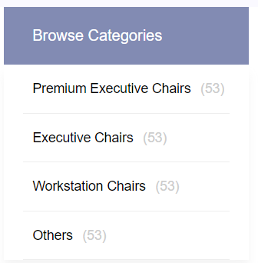 Make this count real items, it is statically displaying “53”

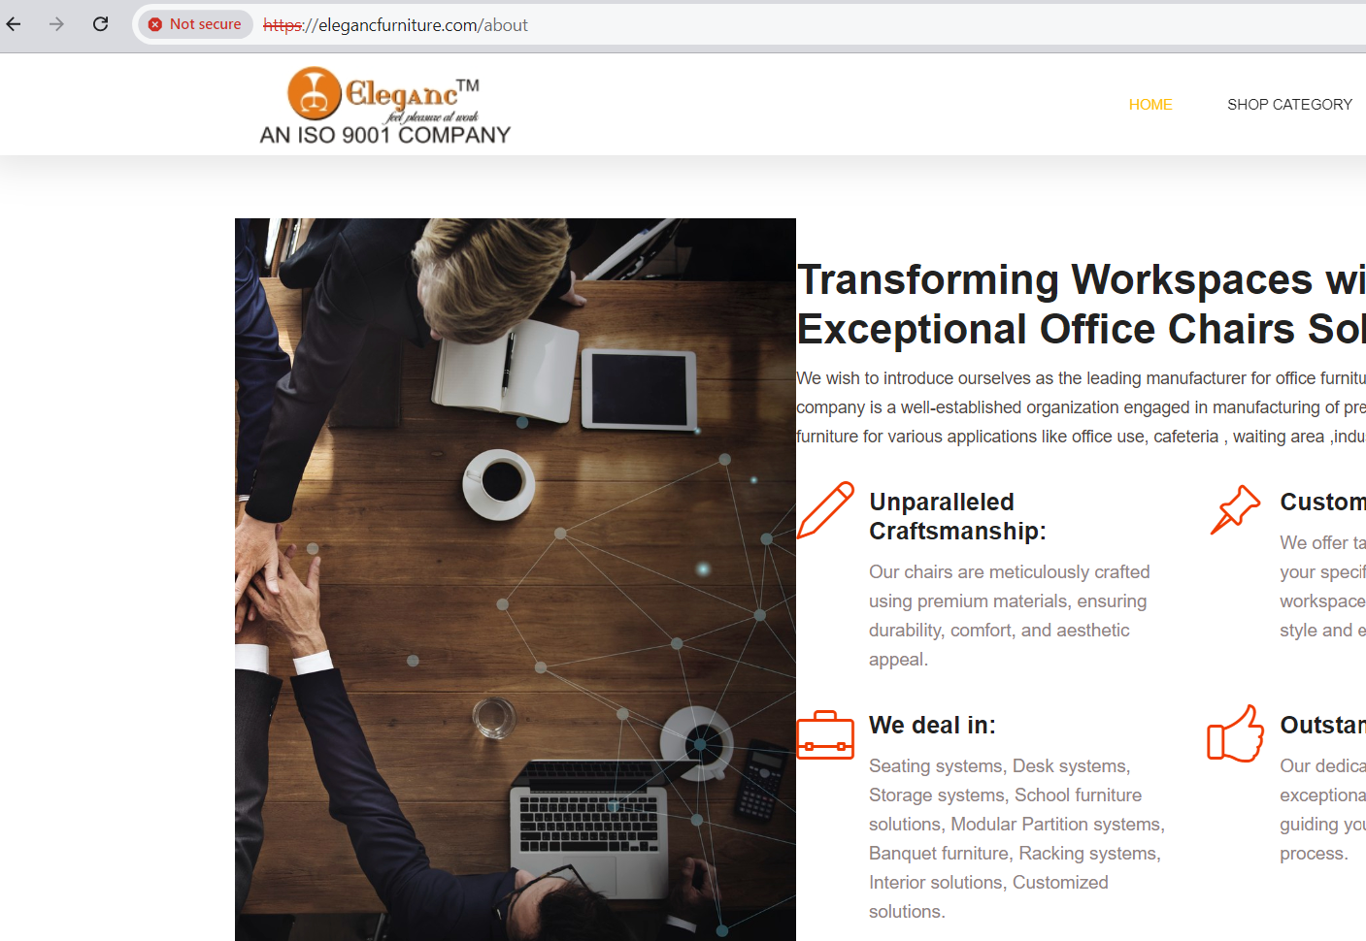

In about page, image is misaligning and icons look too big in some screen sizes.

Make a contact form for “Query Now/Ask Quote” buttons.

The form should store data in a google spreadsheet and also mail it timely to [emsplup@gmail.com](mailto:emsplup@gmail.com)

Add a “Whatsapp button” alongside with chatbot.

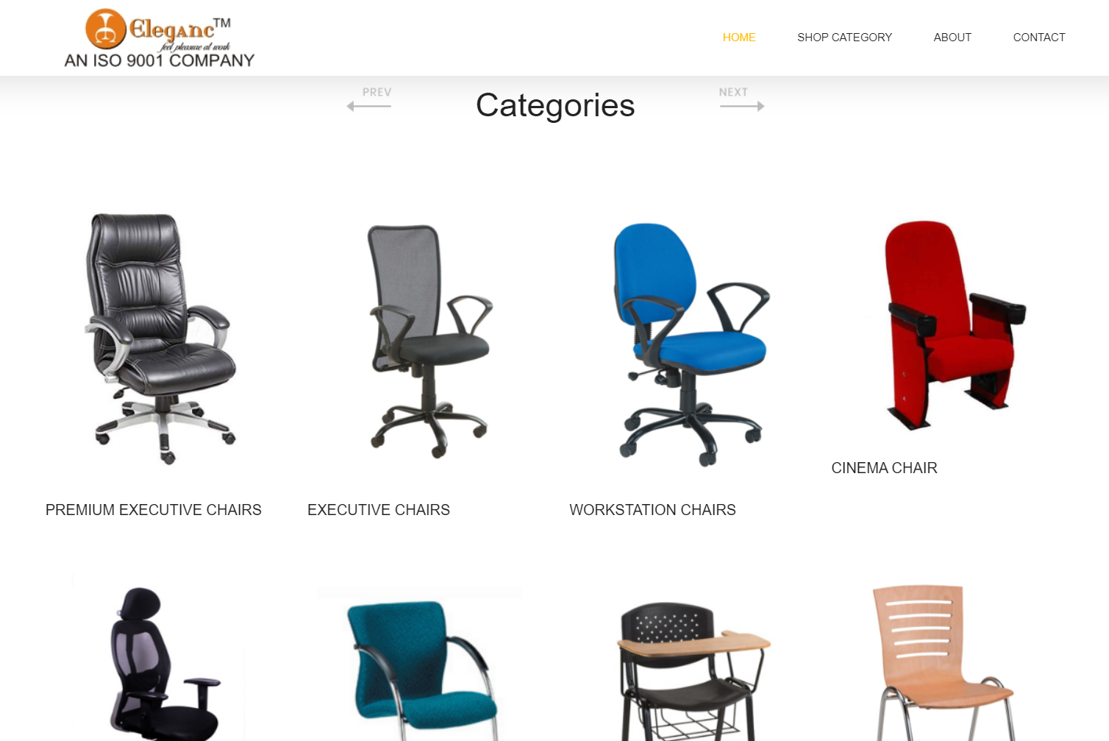

While clicking on these categories pics, it should open up that category like clicking on “Executive chairs image” shall open a link to that page. If pages for some categories are missing, make new pages in the same format and layout as existing ones.

Add a feature of zoom into image on product images. Like if someone hovers over a product for ex EMBC-1, then the image shows a zoom option.

ADD Meta tag, and meta info, keywords in all pages.

List of compulsory tags: “Chairs in noida”, “office chairs”, “office furniture in Noida”, “office furniture in delhi”, “office furniture in greater Noida”, “office furniture in ncr”, “ergonomic chairs Noida”, “ergonomic chairs delhi”, “ergonomic chairs”, “ergonomic chairs greater Noida”, “office chairs manufacturers”, “office furniture manufacturers”, “quality office chairs”, “customized seating solutions”

all categories should be displayed here.

We’ll give some products pics for the categories, those need to be added into it.

If a product has more than one image, those images should come like a slider like in chairsindia.in

Add a new categories “Spare parts” and “Hardware”.